Moving object detection and tracking Using Convolutional Neural Networks

1st Kshama S B
Assistant Professor
Dept of Computer Science and Engg.
Sai Vidya Institute of Technology
Bengaluru,India
kshama.sb@saividya.ac.in
3rd Santhosh K
8th semester, UG student
Dept of Computer Science and Engg.
Sai Vidya Institute of Technology
Bengaluru,India
santhoshk.18cs@saividya.ac.in
1st Vaishnavi A
8th semester, UG student
Dept of Computer Science and Engg.
Sai Vidya Institute of Technology
Bengaluru,India
vaishnavia.18cs@saividya.ac.in
4th Tejas Manu S
8th semester, UG student
Dept of Computer Science and Engg.
Sai Vidya Institute of Technology
Bengaluru,India
tejasmanumanus.18cs@saividya.ac.in
2nd Suhas M
8th semester, UG student
Dept of Computer Science and Engg.
Sai Vidya Institute of Technology
Bengaluru,India
suhasm.18cs@saividya.ac.in

Abstract— Our purpose in this research is to compare transfer learning to CNN when we only have a limited amount of data. The CNN approach necessitates a vast data set, as well as a lot of processing power, GPU, and time. Transfer learning, on the other hand, performs with more accuracy and less complexity in less time when given a small data set and minimal processing power and GPU. As a result, when a smaller data set is available, transfer learning is a more viable alternative for obtaining faster output and more accuracy.
Keywords— Accuracy, Convolutional Neural Network (CNN), Fine-tuning, Processing power, Transfer Learning (TL).

Introduction
Agriculture is an important part of the Indian economy, producing a broad variety of fruits, vegetables, and grains for both internal and export consumption. In terms of fruit output, India is ranked second in the world. When choosing a fruit to buy, smell, shape, and colour are all significant elements to consider. For image classification, we take into account shape and colour in this application. It’s critical to spot any bacterial or fungal development on fruits since they can cause havoc should they become mixed in with the good ones, resulting in a loss of yield.
Convolution Neural Networks (CNNs) are neural networks with one or more convolution layers that are mostly used for segmentation, image classification, and other autocorrelated data. In order to improve accuracy, these layers of the CNN often demand a lot of computational power and GPU. Accuracy of the CNN architecture highly depends upon the three factors namely: Large scale database, high end computational unit and the network depth. It is quite impossible to learn the network parameters of such huge networks over small scale data sets. Convolution is the process of sliding a filter over a picture. Rather than looking at the entire image, the layers assist in focusing on a specific characteristic of the image, which is more effective and useful in classifying the image.
Transfer Learning, on the contrary, is a machine learning approach that utilizes a previously trained machine learning model to produce a new model that is used to tackle a distinct but interrelated problem. When a smaller data set is available and computational capacity is limited, using a pre-trained machine learning model to generate a new model is more efficient way to approach the problem.
CNN has achieved tremendous success in the fields of image classification, voice recognition, and video classification using deep learning technology. Despite its high success rate and accuracy, it is not suitable for real-time applications due to time constraints, high processing requirements, and the requirement for a huge resource database. In such instances, it is preferable to use a lightweight neural network that can support a limited database, computational resources and give output faster while ensuring high accuracy and performance.The CNN model might take days or even weeks to train on a very large data set, whereas by using Transfer learning we cut short this long training process as we use a pre trained model.
In our implementation we will be employing a machine learning model MobileNetV1 that is pre-trained with Image- Net database .In addition to this will also be Fine-Tuning our model, where we will be freezing the initial layers of the model except the last 5 layers and re-training the model to classify the images based on the new data with a very low learning rate to detect the quality of fruits and vegetables.

Literature Survey
There are different approaches had been presented by different researchers starting from background subtraction to CNN. Some of the human tracking methods have been presented in this section.

Human tracking consists of three basic steps for pedestrian tracking: Human detection from sequence of frame, tracking and analysis of the tracking for particular purpose. Deep learning-based low-cost machine vision system for grading the fruits based on their outer appearance or freshness. Various state-of-the-art deep learning models and stacking ensemble deep learning methods were applied to two data sets of fruits. The results of this study show that Efficient Net CNN models and their stacked combinations have the highest accuracy in grading the test set and real samples as compared to the other deep learning models. [1]

A framework for learning and classifying bananas is developed first. It uses neural network technology to detect the fruit's ripening stage.Due to the complexity of the banana fruit's ripening stages, it is necessary to develop image processing tools that can identify the various fresh incoming bunches.The goal is to create an image processing system that can detect the different stages of the fruit's ripening process. This method would help determine the optimal eating quality and the price of bananas. [2]

Computer vision is a widely used technique for processing images. It has enormous potential in terms of image processing and farming.In this paper, we study the various aspects of machine learning for the classification of fruits and vegetables. Through a variety of data sources, we found that SVM achieves better accuracy than other machine learning techniques.In this paper, we perform the Recognition and classification of fruits and vegetables and detection of disease in fruits and vegetables among the horticulture products under the agriculture field using computer vision.[3].

This paper proposed a classification model for maturity status classification of papaya fruits in two approaches, machine learning and transfer learning approach.Overall, the VGG19 is better as VGG19 is based on transfer learning, there is no requirement of feature extraction and feature selection process. Although the transfer learning approach needs complex architecture, high training time and large data sets it is one time only.However, the achieved accuracy in both machine learning and transfer learning is 100% and beat the previous method i.e., 94.7% of accuracy. [4].

A deep learning-based framework for fruit classification was proposed in this work. Two CNN models were investigated in the proposed framework, a small CNN model, and a VGG-16 fine-tuned model. The VGG-16 fine-tuned model achieved excellent accuracy on both datasets.The light CNN model also achieved excellent accuracy on dataset 1 with data augmentation.The performance of the two models has been compared with two other methods in the literature. It was found that the two proposed models outperformed the two existing methods on dataset.[5].
The proposed paper tells us they have created a fuzzy model to check whether the fruit banana is ripe, unripe or overripe. For this they have used Regression Tree Algorithm and also the classification method. This process is evaluating the banana on different ripening stages on the MUSA database.[6]

The proposed paper gives the information that Convolution Neural Network has feature extraction which can be used for object recognition,semantic segmentation and image super-resolution.For object recognition we can use CNN architecture such as AlexNet,VGG16 and VGG19.For hybrid classification we will be using the CNN architecture along with support vector machine classifier.VGG19 CNN Architecture is best comparing with the others. [7]

Women Deep Learning is machine learning technique which depends on supervised,semisupervised and unsupervised learning.For image processing,computer vision and pattern recognition.In working part first it will be working on Deep Neural Network in Deep Learning area and then convolution neural network and the are LeNet,AlexNet,GoogleNet,VGG16,VGG19,Resnet50 etc .[8]

In this paper, it has been discussed there may arise a human error while checking the quality of the fruit so using image acquisition and image classification for checking the fruit quality and three important factors used are image segmentation, image pre-processing, Classifier. In addition to this k-means clustering is used to achieve better improvement of accuracy and speed of the classifier.[9]

In this proposed paper, it is discussed about apple defect detection where first the apple image is captured and then background are deleted and the algorithm used in this paper is e Fuzzy C-means Algorithm and the Nonlinear Programming Genetic Algorithm (FCM-NPGA) and for multivariate image analysis. Using this algorithm the image of apple that is apple is examined every angle so that the defect can be found easily.[10]

Methodology
The dataset being used consists of 14,334 images that haven been obtained from Kaggle. They have been split into train,test and validation data. This consists of 6 classes namely fresh apples, fresh bananas, fresh oranges, rotten apples, rotten bananas and rotten oranges.
Methodology of CNN :
We first load the train data into the model, which then goes through pre-processing, which includes setting the parameters for the target variable and extracting features from the dataset. To train the model on our dataset, we begin by adding convolutional, pooling, normalizing, dropout, and dense layers to the convolutional neural network.
Following the training, the loss and accuracy are calculated, and the model's prediction is assessed. Once the model is complete, we perform tests on the model, which goes through pre-processing and feature extraction before being processed by the prediction model, which then delivers the result.
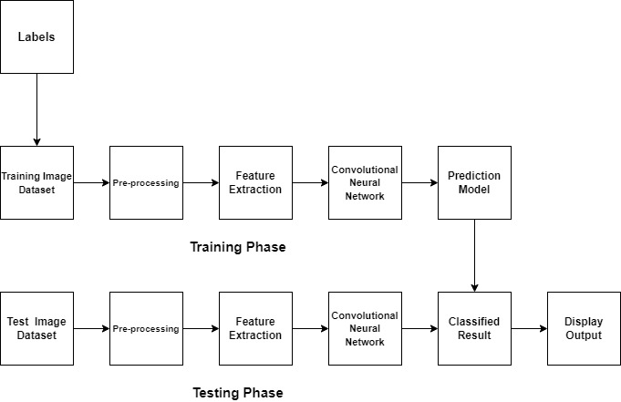

Fig1.Methodology of CNN
Methodology for TL:-
The training data is pre-processed with the use of a mobile net preprocessing function for transfer learning, which includes feature extraction and resizing. Following that, we fine-tune the mobile net to assure better performance with our dataset. This is given to the model as training input. The training is then checked against the validation set for accuracy and loss, as well as to verify if our model is overfitting or underfit . Once the prediction model is complete, we pass our test set to the model, which then produces a classification of fruit quality.
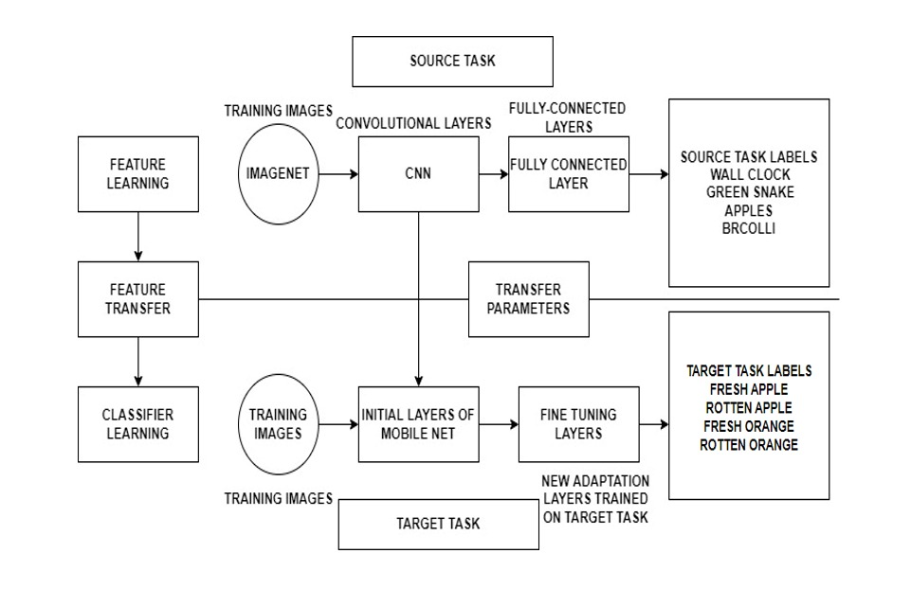
Fig2.Methodology of TL

Algorithm
CNN:
- The OpenCV tool is used in conjunction with TensorFlow and the Keras model. WE then load the data for the train, test and validation.
- We create our CNN model by layering the Convolutional later with the rectified linear activation function, Normalization, MaxPooling and drop layers to avoid over-fitting the model.We build a fully connected dense layer and apply the sigmoid activation algorithm after creating three such CNN layers.
- Lastly we train our model for 50 epochs, using the binary cross-entropy loss function to assess loss and achieve an accuracy of ---- and loss of ------.

TL:
- First, we preprocess the dataset by constructing an input pipeline, in this instance Keras ImageDataGenerator, and running the preprocessing function, which turns the data into a format that the mobilenet understands and normalises the RGB pixels to a range of -1 to 1. We also specify the dimensions of the input photos to be (224,224).
- We perform modification to the fully connected layer and add a dense layer classify the 6 different classes of our dataset using the softmax activation function as we are performing multi- classification.
- We then fine-tune our model by freezing all but the final 5 layers and re-training it with a low learning rate on our dataset.
- Next, we compile using the adam optimizer and the categorical crossentropy loss function as we are multi-classification.
- Finally, we train our models for 100 epochs and attain a training accuracy of 99.99 and a validation accuracy of 95.42, with a training and validation loss of 1.375 and 0.2758, respectively.

Flowchart
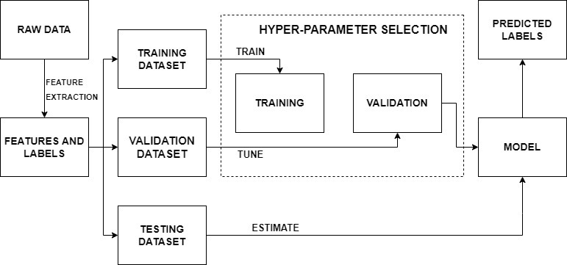
Fig.4. Flowchart of TL

CNN:-
We load the data and then perform preprocessing on the data by adjusting the colour scale and re-sizing the image.
- It then undergoes feature extraction in the convolutional neural network that we created by layering the convolutional layer, max-pooling layer, normalization layer along with a dropout layer to help the model avoid overfitting.
- Finally a dense layer to perform the classification.
- Once the model has been trained it is then compared with the validation dataset for accuracy and loss to check for over/underfitting.
- The trained model further undergoes testing and makes a prediction.
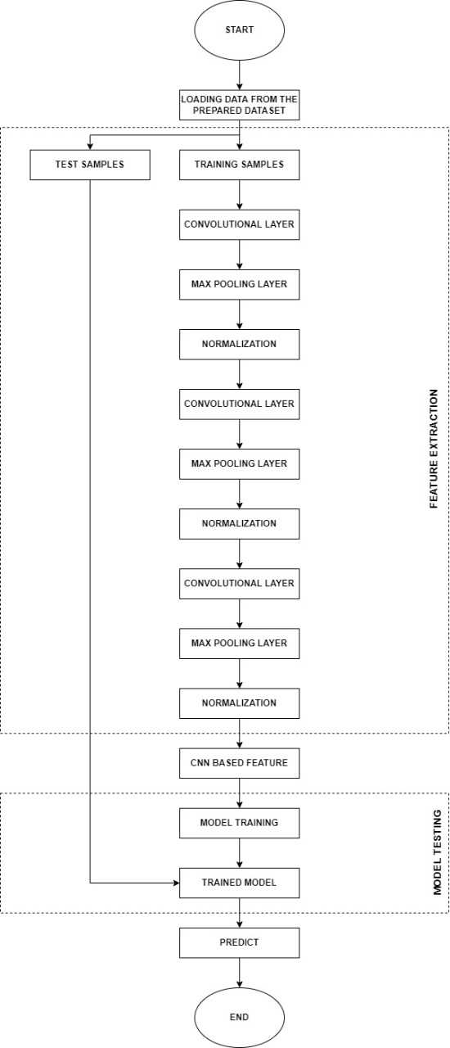
Fig.3. Flowchart of CNN

TL:-
- The mobilenetv1 model is initially trained on the ImageNet database, where it is taught to identify 1000 images using various layers of convolutional neural networks and a fully connected layer.
- These trained models can subsequently be used for our unique implementations. The weights from the previously trained dataset are transferred to the early layers of mobile net, while the final few layers can be fine-tuned/modified and the model re-trained on the unique target task.
- This fine-tuned model undergoes testing with the testing dataset. The trained model is then validated and tested against the test data which then goes on to make predictions.

VI. Result
Below are the results that were obtained from the Transfer learning model:
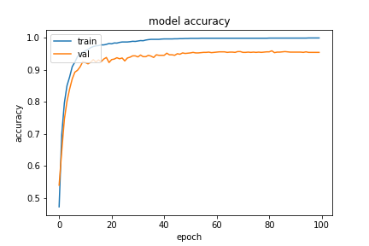
Fig.5.Accuracy graph of TL

The above graph represent the training and validation accuracy of the transfer learning model.
Training Accuracy: 99.91
Validation Accuracy: 95.42
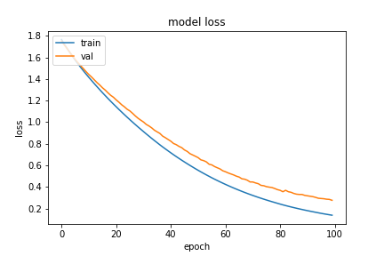
Fig.6. Loss graph for TL

The above graph represent the training and validation loss of the transfer learning model.
Training Loss: 1.37
Validation Loss: 2.75
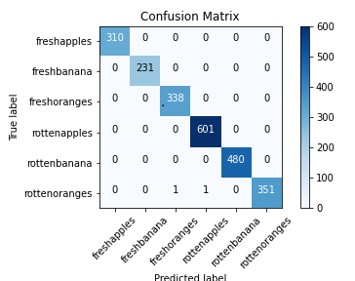

Fig.7.Confusion Matrix

The above diagram represents the confusion matrix generated by the transfer learning model which has performed extremely well by only misclassifying 2 instances in the test set.
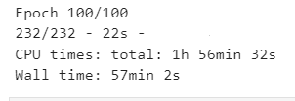
Fig.8 Time taken for TL
Transfer learning takes 57 minutes and 2 seconds to train the model for 100 epochs.
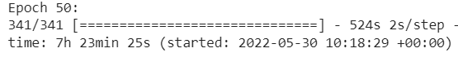
Fig.11 Time taken for CNN

Below are the results that are obtained for the CNN
model:
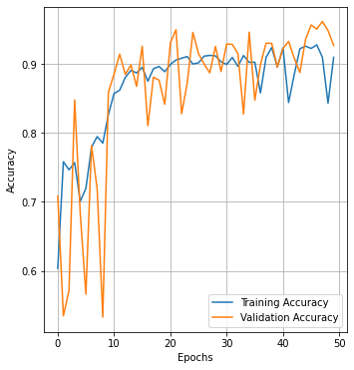
Fig.9.Accuracy graph of CNN

The above graph represent the training and validation
Accuracy of the CNN model.
Training Accuracy: 90.95
Validation Accuracy: 92.66
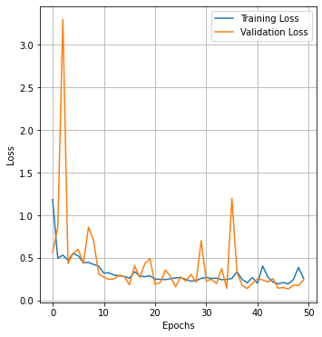
Fig.10.Loss graph of CNN

The above graph represents the training and validation loss for the CNN model:
Training Loss: 2.58
Validation Loss: 2.43

Compared to the TL model the CNN takes 7hrs 23 min and 25s to train the model.

Conclusion
The purpose of this study was to create a model that could produce respectable accuracy ratings in a short amount of time while using little computing resources. We can deduce from the aforementioned data that, when compared to the CNN model, the transfer learning model did exceedingly well in terms of accuracy and time. Not only is the transfer learning model easier to train on the system since it takes up less space, but it can also be used on low-power devices like smartphones. We can also infer that the TL model is 6 times faster at training than the CNN based on the training time comparison.

VII.REFERENCES

- Nazrul Ismail & Owais A.Malik, "Real-time visual inspection system for grading fruits using computer vision and deep learning techniques",IEEE March 2022.
- Mukesh KumarTripathi and Dr Dhananjay D.Maktedar, "A role of computer vision in fruits and vegetables among various horticulture products of agriculture fields: A survey ",IEEE June 2020.
- Santi Kumari Behera, Amiya Kumar Rath and Prabira Kumar Sethy,. "Maturity status classification of papaya fruits based on machine learning and transfer learning approach " ,IEEE June 2021.
- M. Shamim Hossain, Muneer Al-Hammadi and Ghulam Muhammad, "Automatic Fruit Classification Using Deep Learning for Industrial Applications",IEEE October 2018.
- Fatma M. A. Mazen & Ahmed A. Nashat, "Ripeness Classification of Bananas Using an Artificial Neural Network",IEEE January 2019.
- S. Marimuthu and S. M. Roomi, "Particle swarm optimized fuzzy model for the classification of banana ripeness", IEEE Sensors J., vol. 17, no. 15, pp. 4903-4915, Aug. 2017.
- Manali Shaha and Meenakshi Pawar,"Transfer Learning for Image Classification",IEEE: 2nd Conference,April 2018.
- Sajja Tulasi Krishna and Hemantha Kumar Kalluri, "Deep Learning and Transfer Learning Approaches for Image Classification", ISSN:2277-3878,Februry 2019.
- Shweta S.Deulkar;Sunita S. Barve, "Feature based Fruit Quality Grading System using Support Vector Machine ",3rd IEEE International Conference, pp. 96-104, 2018.
- W. Zhang, J. Hu, G. Zhou, and M. He, ‘‘Detection of apple defects based on the FCM-NPGA and a multivariate image analysis,’’ IEEE Access, vol. 8, pp. 38833–38845, 2020.
- Yo-Ping Huang;Tzu-Hao Wang;Haobijam Basanta, "Using Fuzzy Mask R-CNN Model to Automatically Identify Tomato Ripeness",IEEE 2020.
- ] F. Garcia, J. Cervantes, A. Lopez, and M. Alvarado, ‘‘Fruit classification by extracting color chromaticity, shape and texture features: Towards an application for supermarkets,’’ IEEE Latin Amer. Trans., vol. 14, no. 7, pp. 3434–3443, Jul. 2016
- M. B. Garcia, S. Ambat, and R. T. Adao, ‘‘Tomayto, tomahto: A machine learning approach for tomato ripening stage identification using pixel-based color image classification,’’ in Proc. IEEE 11th Int. Conf. Humanoid, Nanotechnol., Inf. Technol., Commun. Control, Environ., Manage. (HNICEM), Laoag, PA, USA, Nov. 2019, pp. 1–6.
- F. Garcia, J. Cervantes, A. Lopez, and M. Alvarado, ‘‘Fruit classification by extracting color chromaticity, shape and texture features: Towards an application for supermarkets,’’ IEEE Latin Amer. Trans., vol. 14, no. 7, pp. 3434–3443, Jul. 2016. P. Li et al., "Deep convolutional computation model for feature learning on big data in internet of things", IEEE Trans. Ind. Inform., vol. 14, no. 2, pp. 790-798, Feb. 2018.
- Z. Gao, L. Wang, L. Zhou and J. Zhang, "HEp-2 cell image classification with deep convolutional neural networks", IEEE J. Biomed. Health Inform., vol. 21, no. 2, pp. 416-428, Mar. 2017.
- C. Hu, X. Liu, Z. Pan, and P. Li, ‘‘Automatic detection of single ripe tomato on plant combining faster R-CNN and intuitionistic fuzzy set,’’ IEEE Access, vol. 7, pp. 154683–154696, Oct. 2019.
- X. Liu, D. Zhao, W. Jia, W. Ji, and Y. Sun, ‘‘A detection method for apple fruits based on color and shape features,’’ IEEE Access, vol. 7, pp. 67923–67933, 2019.
- G. Muhammad, "Date fruits classification using texture descriptors and shape-size features", Eng. Appl. Artif. Intell., vol. 37, pp. 361-367, 2015.
- V. Leemans and M.-F. Destain, ‘‘A real-time grading method of apples based on features extracted from defects,’’ J. Food Eng., vol. 61, no. 1, pp. 83–89, Jan. 2004.
- D. Li, M. Shen, D. Li, and X. Yu, ‘‘Green apple recognition method based on the combination of texture and shape features,’’ in Proc. IEEE Int. Conf. Mechatron. Automat. (ICMA), Takamatsu, Japan, pp. 264–269, Aug. 2017.

:

Training Loss: 1.37
Validation Loss: 2.75

IMPLEMENTATION
Proposed platform is implemented using HTML, CSS, JavaScript and Bootstrap at front end. Python Django is used for backend development. MongoDB is used for databases. Fig.2 shows the Signin page created for customer Fig.3 shows the customer template. Fig. 4 shows the registration page for business profile creation, Fig. 5 shows vendor profile page. Similarly there will be a user account and admin account.
Find me’ is the app where an entrepreneur will sign up his business and he will be showcased largely through our database. Finding the right service for the consumer is our prime objective. All the services whether food, clothing, furniture, electronics or any blue collar services, everything can be availed under one roof. The small business would be interacting directly to the consumer without any third party involvement. The service providers can create their profile and promote the products that they want to sell. The charge is completely waived off for any business that would like to showcase themselves on our platform. There are no in-app purchases or any kinds of ads that are being popped up to the consumer. Pictures, ratings, reviews, enquiries, information of the establishment is made available to the consumers.

Fig. 2. Sign in Page
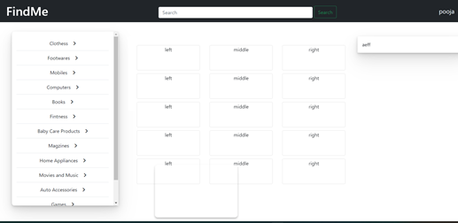
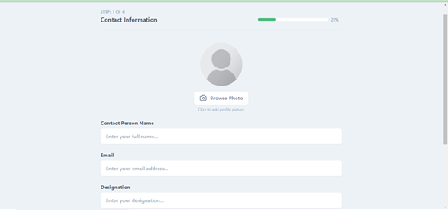
Fig. 3. Customer template
Fig. 4. Business Profile Register Page
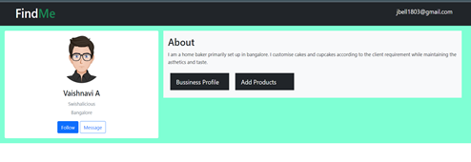
Fig. 5. Vendor Profile Page

CONCLUSION
In this era of modern technology, everything has become digital and cybernetic and all the businesses are adapting this method for the growth of their business. As there has been a sudden rise in small businesses who have limited budgets and sometimes don’t have the resources to market their products. Due to limited audience on social networking platforms, it can be quite difficult for marketing their business. In this project, the application is designed and developed such that it allows entrepreneurs to sign up their business and be showcased to their target audience largely through the database. The application also provides a platform for users to find the service they require. All services whether food, clothing, furniture, electronics or any blue collar services, all can be availed under one roof. The users can interact with the vendors directly. This project has developed an application that is suitable to work on majority of existing hardware i.e. Mobile devices or desktops with a web browser. The system will help entrepreneurs to showcase their business, and the consumers to find a service they would like to avail.

